Directions
Read each advertisement and answer the questions that follow.

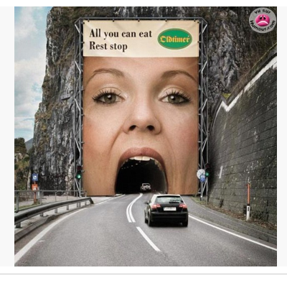
- Why do you think the author chose to advertise in this way? Use information from the advertisement to explain your answer.

- Complete the analogy – billboard:car :: rest stop: __________________
  - food
  - break
  - visitors
  - mountain
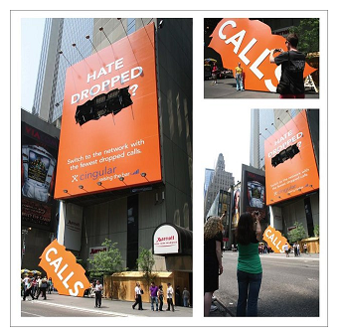

Switch to the network with the fewest dropped calls. Cingular
Marriott Hotel

- What is ad’s underlying message?
- Dropped calls happen often.
- Dropped calls are dangerous.
- Dropped calls are bothersome.
- Dropped calls happen mostly in town.

- What is the intended message of this ad?
- To bring people into the hotel.
- Cingular spends a lot on advertising.
- Dropped calls do not happen with Cingular.
- Switching to Cingular will reduce dropped calls.

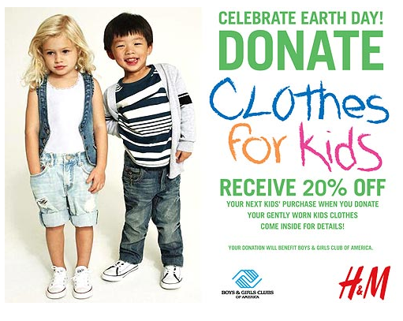
- The intended message of this ad is for adults to─
- shop at H&M.
- only buy clothing at 20% off.
- give away their kids old clothing.
- bring their children to the Boys and Girls Club.

- The underlying message in this ad is─
- donations are expected.
- reusing clothing is good for the planet.
- dress children more appropriately for school.
- participate in Boys and Girls Club sports programs.

- Why might the words “Clothes for Kids” be in a different font?
- To connect and focus on children.
- To poke fun at the way kids write.
- To show the seriousness of the problem.
- To draw attention to the store that might profit.

- Explain why the author included a photograph of two children? Use information from the advertisement to support your answer.

- Describe a strength and a weakness of this advertisement. Use information from the advertisement to explain your answer.

- The author most likely changed the font size for the mailing address to encourage people to
  - race cars
  - use the website
  - type all schoolwork
  - purchase this program
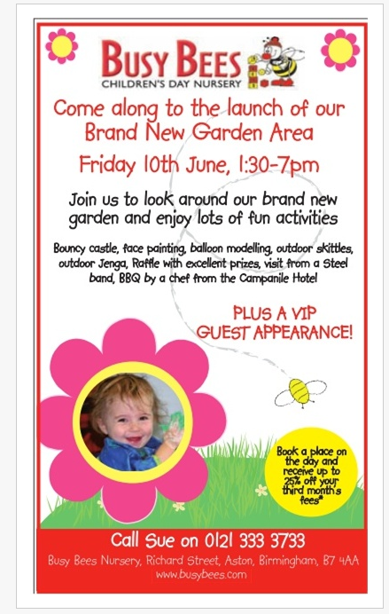

- Do the design features enhance the author’s message? Use information from the advertisement to support you answer.

Grade 6, Unit 7 Analysis
Focus | Questions
Media Messages | 3, 4, 5, 6, 9
Media Format | 1, 7, 8, 9, 10, 11
Word Study | 2

*Constructed Response
1. CR 7. A
2. C 8. CR
3. C 9. CR
4. D 10. B
5. A 11. CR
6. B
Constructed Response Rubrics
- Why do you think the author choose to advertise in this way? Use information from the advertisement to explain your answer.
Score | Description
2 | The response is an adequate explanation about the author’s choice in advertising, supported with relevant information from the advertisement.
1 | The response is a partial explanation about the author’s choice in advertising, supported with somewhat limited information from the advertisement.
0 | The response is totally incorrect or irrelevant.
Good responses might include:
The author chose to advertise in this way mainly for dramatic effect. You simply cannot miss this ad while driving, and it is humorous. The idea of going into someone’s mouth may make you feel hungry, which will lead you to stop at an all you can eat rest stop. Also, there is a play on words – the girl is eating all the cars, and you can eat all you want at the rest stop.

- Explain why the author included a photograph of two children? Use information from the advertisement to support your answer.
Score | Description
2 | The response is an adequate explanation about why the author included the photograph, supported with relevant information from the advertisement.
1 | The response is a partial explanation about why the author included the photograph, supported with somewhat limited references from the essay.
0 | The response is totally incorrect or irrelevant.
Good responses might include:
The author chose to include the photograph for emotional appeal. It provides a visual and may be a reminder of your own children- which can stir up emotions. The girl appears sad in the photo. It also showcases the different types of clothing that people can donate, or possibly shows you what “gently used clothing” might look like.

- Describe a strength and a weakness of this advertisement. Use information from the advertisement to explain your answer.
Score | Description
2 | The response is an adequate explanation that describes a strength and weakness, supported with relevant information from the advertisement.
1 | The response is a partial explanation that describes a strength and weakness, supported with somewhat limited references from the advertisement.
0 | The response is totally incorrect or irrelevant.
Good responses might include:
Strength and weakness on the message:
The ad is very visual and has a “winner” theme. It makes me want to be a winner if I use the Dream Writer system. It is a bit confusing too. The product is not clear. They appear to be selling DreamWriters, but they are talking about scholarships. The company is sending a confusing message.
Strength and weakness on the format:
The strength of the ad is the connection between the font choices and the pictures. For example the word WHEELS is in large, bold font. The wheels on the car are obvious in the photograph and they heading towards the man with the trophy. Whereas the DreamWriter is much smaller, which may show that it is not as important in the ad. That might lead to confusion for the reader because you may not know that the ad is selling the DreamWriter and sponsoring a scholarship.

- Do the design features enhance the author’s message? Use information from the advertisement to support you answer.
Score | Description
2 | The response includes an answer and shows satisfactory understanding of whether the design features enhance the author’s message, supported with relevant information from the advertisement.
1 | The response includes as answer and shows limited understanding of whether the design features enhance the author’s message, supported with somewhat limited references from the essay.
0 | The response is totally incorrect or irrelevant.

Yes, the design features enhance the message because they are trying to get people to come to their new garden area, so they included a flower, bumblebee, and grass in the design. This makes me think of a garden.

No, the design features do not really have anything to do with a day nursery. They mention a bouncy castle, face painting, and even a VIP visit. Nothing in this ad seems to go along with those ideas.

