Chevy Ad
- The author repeats the phrase “taking charge” in order to emphasize the company’s—
- new direction
- need to be the best
- use of American products
- power over other carmakers
- Which tone is expressed in the ad?
- casual
- cheerful
- idealistic
- dramatic
- Using a sentence fragment in line 6, “On our Chevrolet products,” makes the reader—
- focus on the brand
- stop to reflect on a car
- gloss over the products
- comprehend the technology
Honda
- What tone is expressed by this ad?
- confident
- sentimental
- argumentative
- straightforward

- Does the design of the ad fit with Honda’s slogan “The Power of Dreams?” Use information from the ad to explain your answer.

- The persuasive technique Honda uses makes the reader feel they can 
- be one of the crowd
- push their boundaries
- support a good company
- become an expert rider

Lunar White

Does this ad make you want to use Lunar White toothpaste? Explain your answer using information from the ad and your knowledge of persuasive techniques.

Why do you think the company chose to advertise the product on a billboard?
- remind kids of a healthy habit
- to avoid lengthy text
- utilize lighting effects
- appeal to a specific audience

Tylenol
- What are the advantages of placing this ad for Tylenol on a billboard? Explain your answer using information from the ad and your knowledge of persuasive techniques.

Hank’s Root Beer & Cerebos Salt
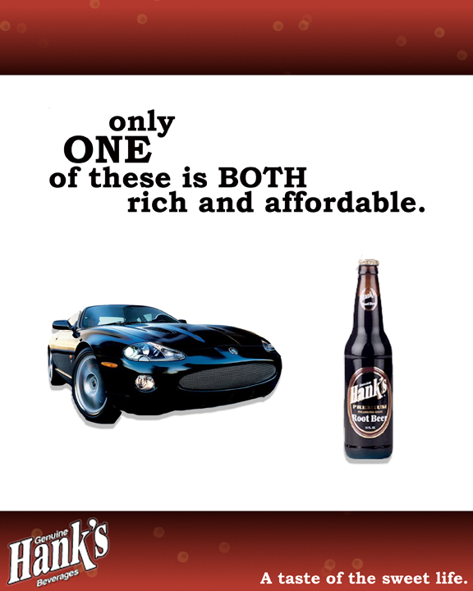
- Look at the formatting and design techniques for the Hank’s Root Beer and Cerebos Salt advertisements. Which ad’s design better enhances the snob appeal more effectively?
- Which words indicate the use of a snob appeal in the Hank’s Root Beer ad?
- one, both
- only, these
- one, rich
- rich, affordable
McDonalds
- The underlying message of this The underlying message of this ad is to convey the sandwich is 
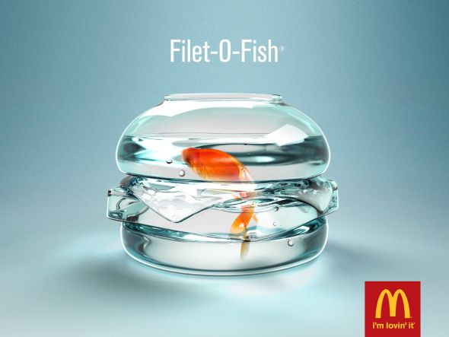
- cold
- free
- fresh
- trendy

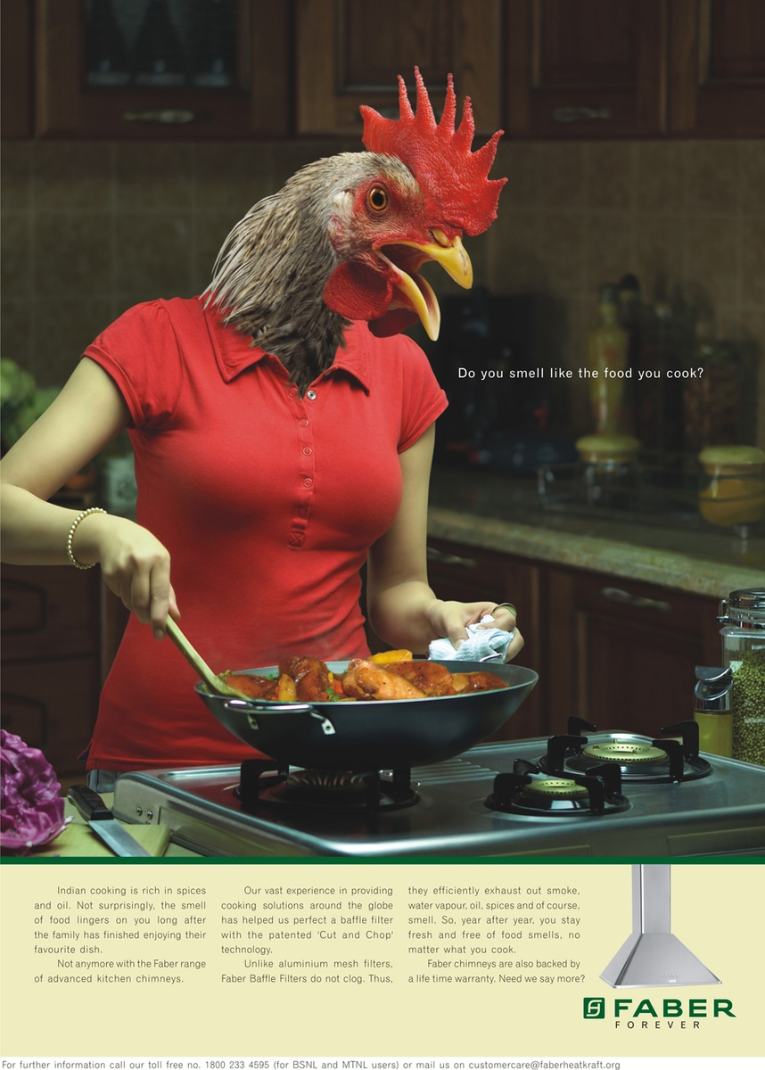
Various types of cooking are rich in spices and oil. Not surprisingly, the smell of food lingers on you long after the family has finished enjoying their meal.
Not anymore with the Faber stove with advanced cooking chimneys.
Our vast experience in providing cooking solutions around the globe has helped us perfect a baffle filter with the patented ‘Cut and Chop’ technology.
Unlike aluminum mesh filters, Faber Baffle Filters do not clog, working like a strong fan. Thus, they efficiently exhaust out smoke, water vapor, oil, spices, and of course, smell.
So, year after year, you stay fresh and free of food smells, no matter what you cook.
Faber chimneys are also backed by a lifetime warranty.
Need we say more?

(bottom text is enlarged in the box to the right)
Faber
- Replacing the human head with the chicken head is persuasive because it—
- shows the product
- shows good ethics
- provides nostalgia
- provides a shocking visual

- The ad states that Faber has “vast experience…around the globe” in order to —
- sound credible
- appear reliable
- appear sophisticated
- prove their warranty

- The underlying message of this ad is
- that cars can harm animals
- the car has a security system
- this car ranks high in comfort
- your car might not be the safest
- The main reason the author chose to use a minimal amount of text because
- it costs less
- simplicity can be effective
- more text might be confusing
- an animial is included

